COMU3150

**ASSIGNMENT 1: CREATE**

**Social Media Strategy**

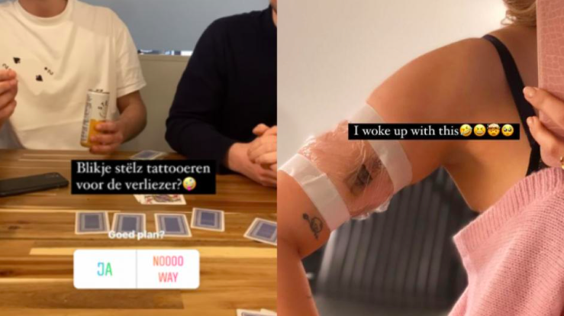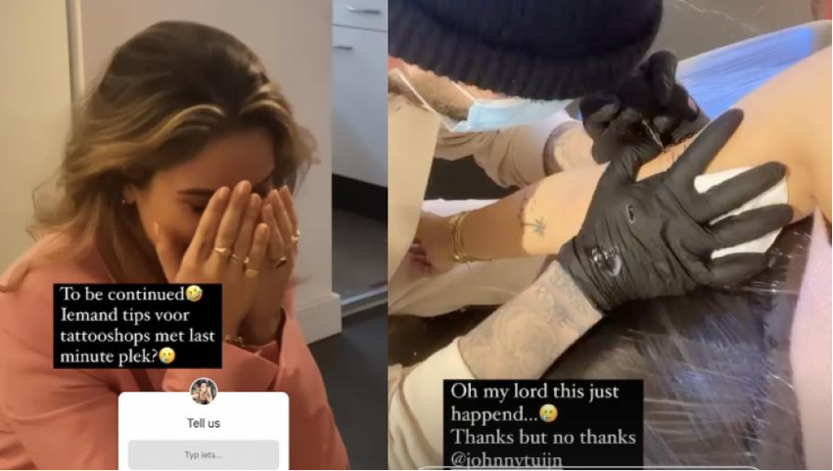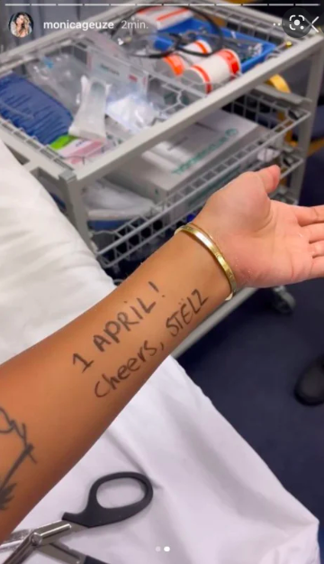

Daphne Post

47556100

19th August 2022

**Link to video:** <https://vimeo.com/739501366>

**Objectives**

*What are you hoping to achieve through this video? For example, comments, likes, shares, click-throughs, views, etc.*

Through this video, I am hoping to reach as much of my target audience as possible to inform and get their minds going about this topic. Therefore, it would be nice if the video would get a lot of shares, since that means that more people will end up seeing the video. Moreover, it would be nice to know that the video is being appreciated by getting likes on the video. However, since I know from experience that not everyone takes the effort to comment on a video or even like the video, I find these measures less important than the number of views. I am hoping to create content that people will keep watching and even remember after they’ve closed the app.

**Target Audience**

*Who is the target audience for this video?*

The target audience for this video is people between the age of 16 and 24 who may have an interest in studying at UQ in the future. Moreover, since the video will be posted on TikTok, the target audience should use a social media platform like TikTok.

**Tactic**

*What is your communication and creative tactic to reach and engage this target audience?*

My communication tactic would be the platform that is used: TikTok. It is known that 50% of the TikTok users is below the age of 30 and that the users spend on average an entire hour per day on the app. Therefore, considering my target audience, this platform would be most suitable to distribute my video. Moreover, I will be using a caption that arouses curiosity in combination with hashtags. Generally, TikTok’s that use hashtags in their caption are receiving more views.

The creative tactic that I will be using is by telling a little lie in the first few seconds of the video, which will (hopefully) get the users attention and stop them from scrolling. Since it only takes a user 3 seconds to determine whether they want to continue watching this video or not, I will be starting off with a shocked cry, like “OH MY GOD! Have you heard?”. After an opening like that, you wouldn’t easily scroll past the video. Or at least, I hope so.

**Goal**

*What are you trying to get your target audience to do or think?*

The main goal of the video is that I want to raise awareness about the promotional culture that we live in. A big part of my audience has probably ever heard of this phenomenon and know that there is a lot of surreptitious advertising, but I don’t think they know how far this type of marketing and promotion goes. By giving them the ‘experience’ in the beginning themselves (by telling a lie that they were about to share with friends), I hope that the video will impress them and that they will remember it. My goal doesn’t involve a real action, I don’t aim to get people to actually do something other than at most sharing the video or share their thoughts about the promotional culture with someone.

**Evaluation Metrics**

*How will you measure the effectiveness of this video? For example, how many comments, likes, or shares etc.*

Since I know from personal experience that people like only a small amount of the videos that they enjoyed watching, I will not be measuring the effectiveness of this video by means of likes or comments. Moreover, I don’t necessarily need people to ‘like’ my video, since it is more of an informative video than a likable video. Instead, I find the number of views and shares more meaningful, since the more the video is shared, the more people will see the video and hopefully think about the message I’m trying to convey.

**Resources**

Bhandari, A. & Bimo, S. (2022). “Why’s Everyone on TikTok Now? The Algorithmized Self and the Future of Self-Making on Social Media”. Social Media + Society.

https://doi.org/10.1177/20563051221086241

Craig, D., & Cunningham, S. (2017). “Toy unboxing: living in an (unregulated) material world”. Media International Australia, 163(1), 77–86

Geboers, M. A., & Van De Wiele, C. T. (2020). “Machine Vision and Social Media Images: Why Hashtags Matter”. Social Media + Society. https://doi.org/10.1177/2056305120928485

Hawker, K. & Carah, N. (2021) “Snapchat's augmented reality brand culture: sponsored filters and lenses as digital piecework”. Continuum. DOI: https://doi.org/10.1080/10304312.2020.1827370

Levy, J. (2017) “Of Mobiles and Menses: Researching Period Tracking Apps and Issues of Response-Ability”. Studies on Home and Community Science 11(2):108-115. doi:10.1080/09737189.2017.1420400

Montag, C. & Yang, H. & Elhai, J.D. (2021). “On the Psychology of TikTok Use: A First Glimpse From Empirical Findings”. Digital Public Health.

https://doi.org/10.3389/fpubh.2021.641673

Powers D. & Greenwell D. (2017) "Branded fitness: Exercise and promotional culture". Journal of Consumer Culture,17(3): pp (523-541). doi:10.1177/1469540515623606.